**Sales order --** 69447

**Submit workflow background process**

**It will call**

**Autoinvoice Import Program**

**ADS, (Autoinvoice Master Program)**

**Invoice**

SELECT interface_header_attribute1, interface_header_attribute2,

interface_header_attribute3, interface_header_attribute10

FROM ra_customer_trx_all

WHERE trx_number = '10047320'

interface_header_attribute1*-- sales order number*

interface_header_attribute2- sales order typ

interface_header_attribute3- delivery id

interface_header_attribute10*-- ware house*

select * from ra_customer_Trx_lines_all where customer_trx_id='1207195' and line_type='TAX'

select due_date,amount_due_original,amount_due_remaining from ar_payment_schedules_all where customer_trx_id='1207195'

**link between sales order number and invoice number**

**or link between om and ar module**

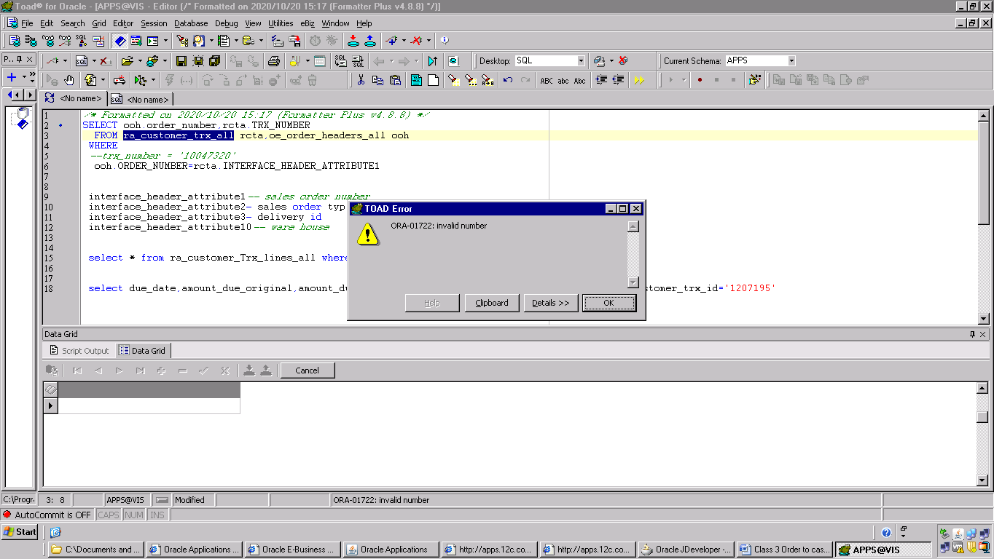

**link between sales order number and invoice number**

**or link between om and ar module**

**table alias ,column alias in oracle**

**header level join**

SELECT ooh.order_number, rcta.trx_number

FROM ra_customer_trx_all rcta, oe_order_headers_all ooh

WHERE trx_number = '10047320'

AND TO_CHAR (ooh.order_number) = rcta.interface_header_attribute1

**Line level join**

SELECT ooh.order_number,rcta.sales_order

FROM ra_customer_trx_lines_all rcta, oe_order_headers_all ooh

WHERE customer_trx_id='1207195'

AND TO_CHAR (ooh.order_number) = rcta.sales_order

**Line to line**

SELECT rctla.sales_order

FROM oe_order_lines_all oola, ra_customer_trx_lines_all rctla

WHERE TO_CHAR (oola.line_id) = rctla.interface_line_attribute6

AND customer_trx_id = '1207195'

**How to display open invoices ??**

SELECT * FROM Ra_customer_trx_all where complete_flag='Y' and org_id=204

**How to display “bill to” customer name and bill to customer number**

select hp.party_name,

hca.account_number

from ra_customer_trx_all rcta,hz_parties hp,hz_cust_accounts hca

where hp.party_id=hca.party_id

and hca.cust_account_id=rcta.bill_to_customer_id

and rcta.TRX_NUMBER='10047320'

**How to display “ship to” customer name and bill to customer number**

select hp.party_name,

hca.account_number

from ra_customer_trx_all rcta,hz_parties hp,hz_cust_accounts hca

where hp.party_id=hca.party_id

and hca.cust_account_id=rcta.ship_to_customer_id

and rcta.TRX_NUMBER='10047320'

**credit memo – negative amount**

**how to derive credit memo ?**

select rcta.TRX_NUMBER invoice_number, credit.TRX_NUMBER credit_number from

ra_customer_trx_all rcta,ra_customer_trx_all credit

where rcta.CUSTOMER_TRX_ID=credit.PREVIOUS_CUSTOMER_TRX_ID

and rcta.TRX_NUMBER='10047320'

*-- self join*

**Create accounting**

**Receipt**

**Transfer to gl**